* Snowflake offers data storage, processing and analytical solutions on cloud platforms which are fast, easy to use.
* Snowflake has 3 layer architecture:

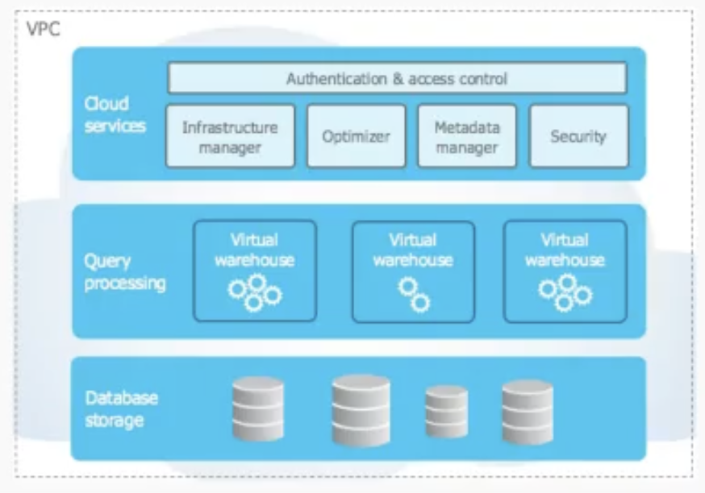

* + Cloud service
  + Query processing
  + Database storage
* It stores data in small chunks of 50-500 MB when uncompressed and 10-100 MB when compressed.
* Micropartions are made in the sequence which we data insert in.
* Warehouse size varies XS to 5XL i..e t shirt size.
* Scale out is adding more CPUs and running them parallely whereas Scaling up is adding RAM and Hardware to existing CPU. Scale up is traditional but has limitations and scale out is expensive but has advantages as well,
* In snowflake, scaling of storage and processing layer can be done independently upto infinity. In other warehouses we don't have this much control for e.g. Bigquery.
* Intelligence here is because of metadata, other warehouses do not use metadata to such extent.
* Spark is data processing and not a data warehouse.
* Snowflake is a Saas i.e. software as a service. It cannot be downloaded, it is hosted on the web and also known as On demand software i.e. you pay only when you require it.
* Main cloud platforms are

1. AWS i.e. Amazon web services.
2. GCP i.e. Google cloud platform.
3. Microsoft Azure

* Snowflake can be hosted on any cloud platform from above but Google Big query and Amazon redshift can only be hosted on their respective clouds.
* Also as these cloud platforms are location specific i.e. they are not available everywhere so using their Warehouse gives you limitation of a region. But Snowflake allows you to work anywhere.

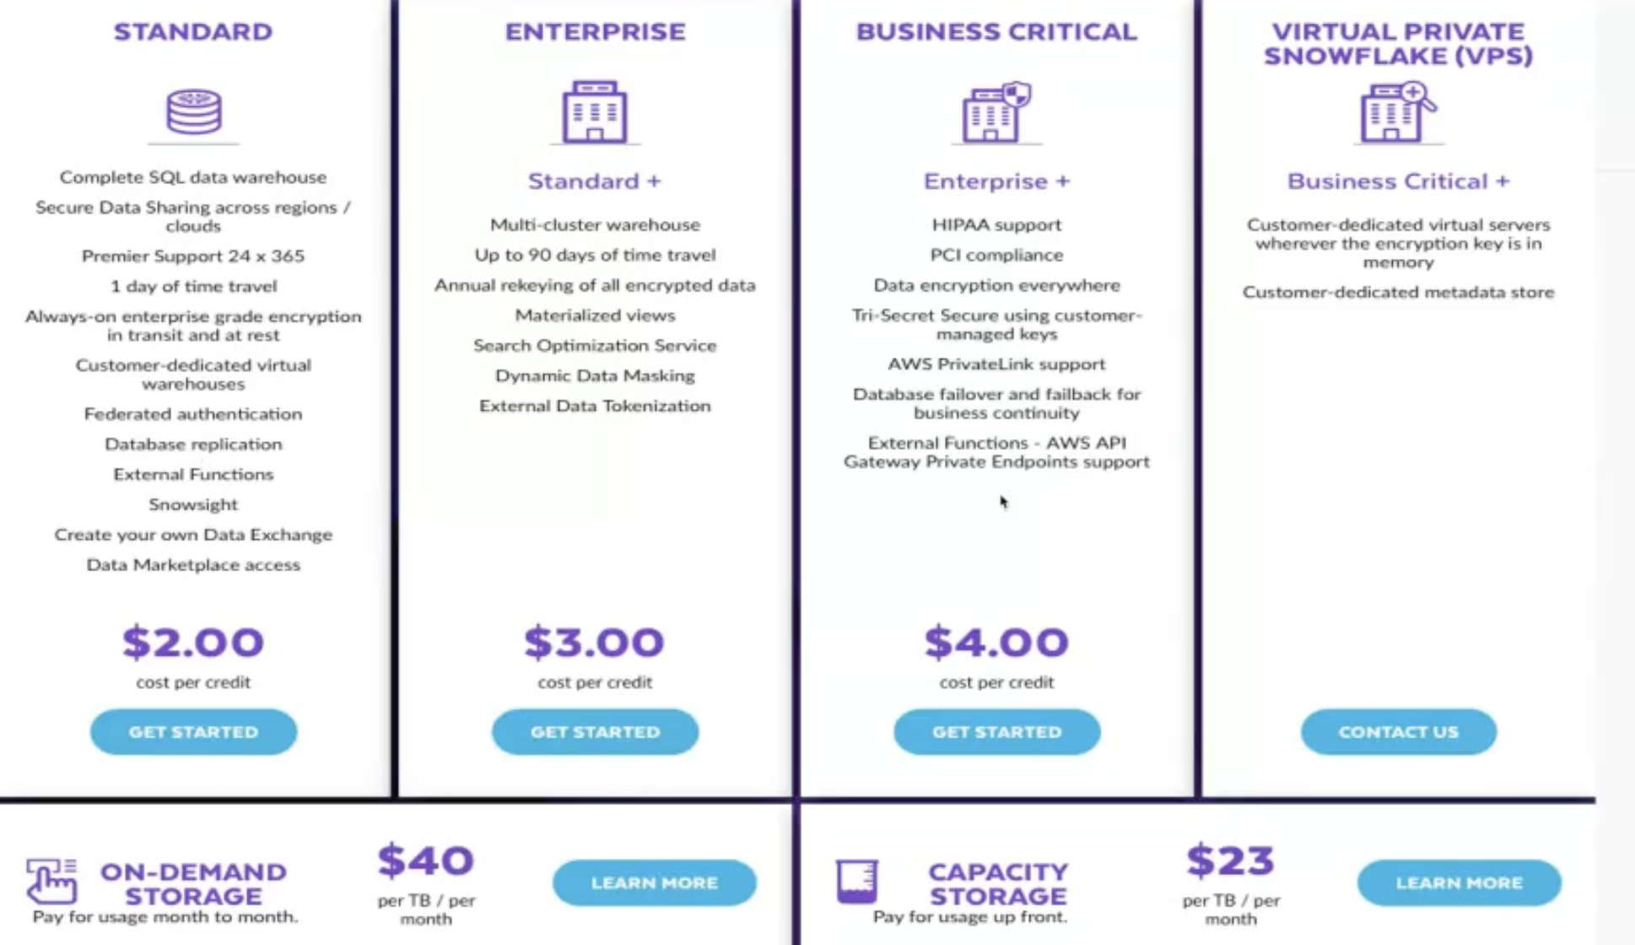

* Some features are only available with AWS, so while choosing this is to be kept in mind.

**Overview of key features:**

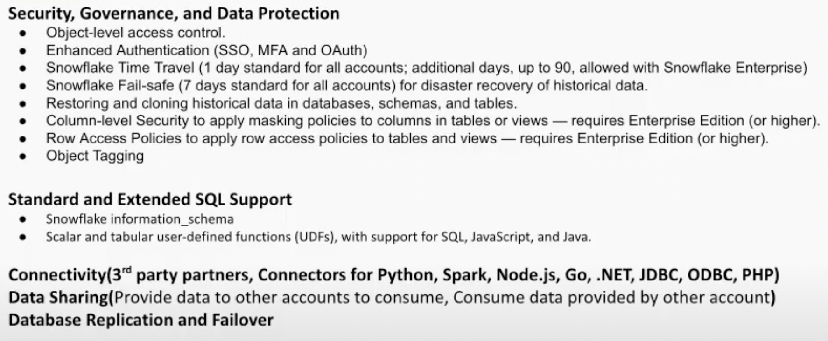

* Authorisation**:**  It decides what information user is allowed to access. And Authentication is validating the identity of user. https://www.logicmonitor.com/blog/what-are-the-different-types-of-authentication
* Time travel: Enable user to access historical data i.e. data that has been modified or deleted.
* Fail safe: Once data is deleted, Fail safe stores data for 7 days and we connect access that, we need to contact customer support
* Time travel and Fail safe require extra storage i.e. costing more.
* Restoring and cloning data.
* Column level security, Row level security, masking policies: PII or personally identifiable information i.e. personal ids and nos of people, it can be shown only to particular people i.e. for some roles.
* Object tagging: Tag any object with masking.
* Connectivity for JDBC, ODBC, PHP https://www.geeksforgeeks.org/introduction-to-jdbc/
* Data sharing: Data is not duplicated but using meta data, data is shared and only computation cost is applied to them. For non snowflake user, we can provide reader access and they can compute resources from our account.
* Number of clusters tell about the scaling, Min and max cluster option exists.

**Overview of access control:**

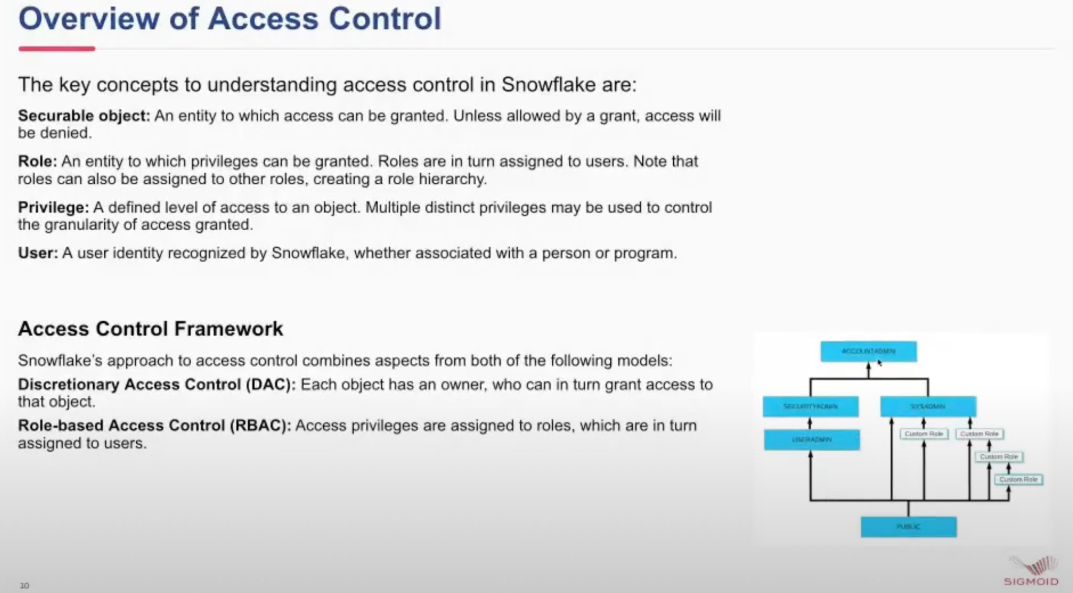

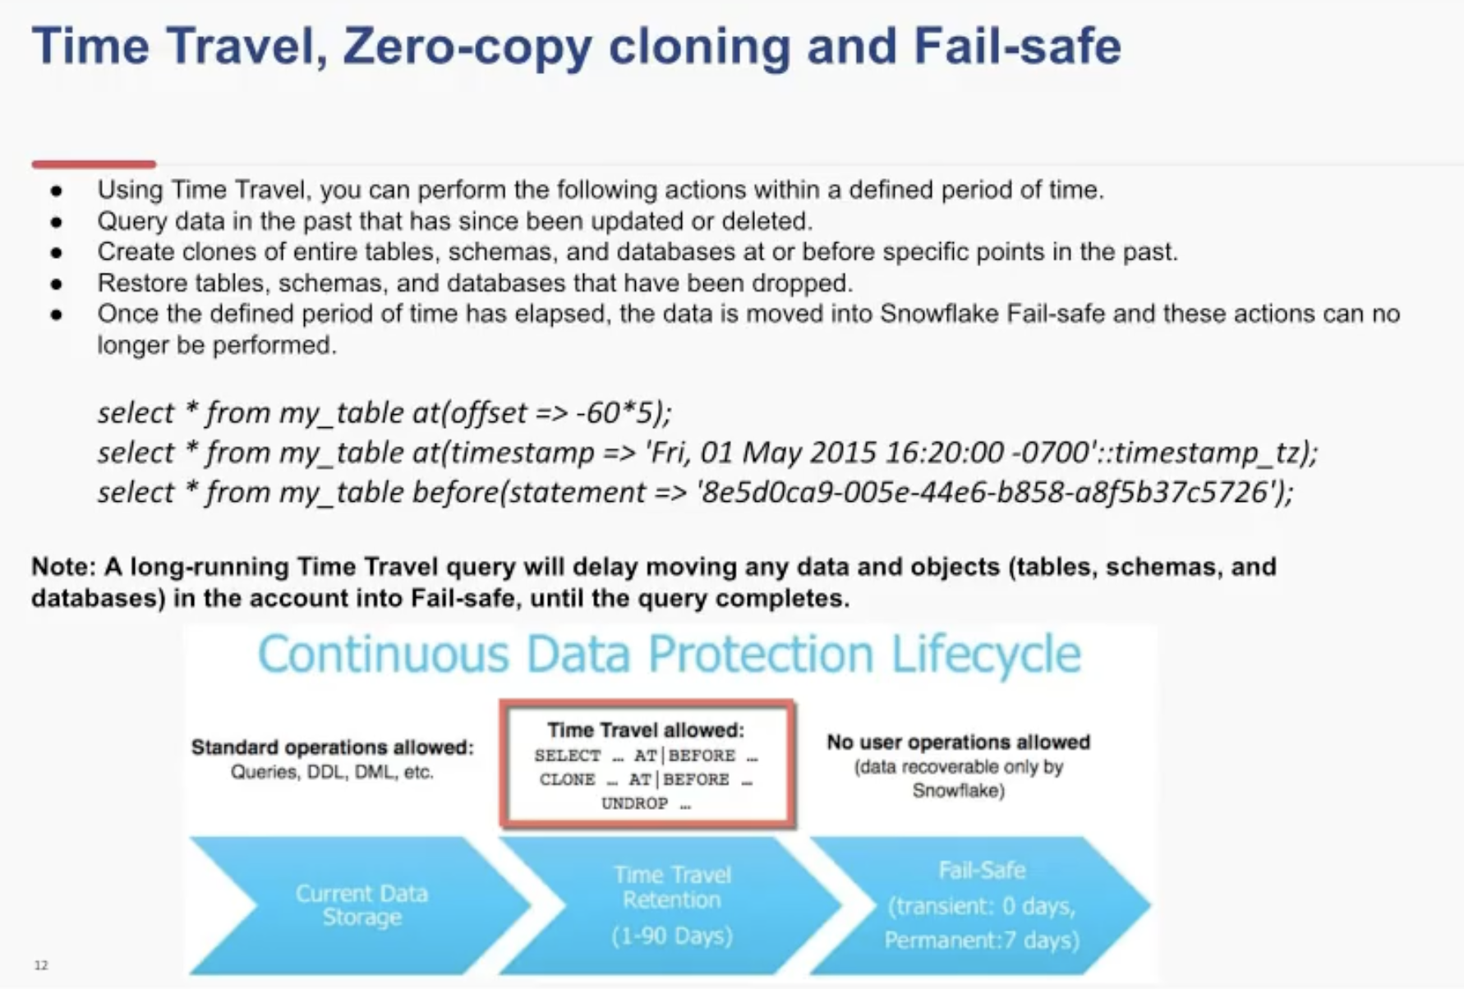

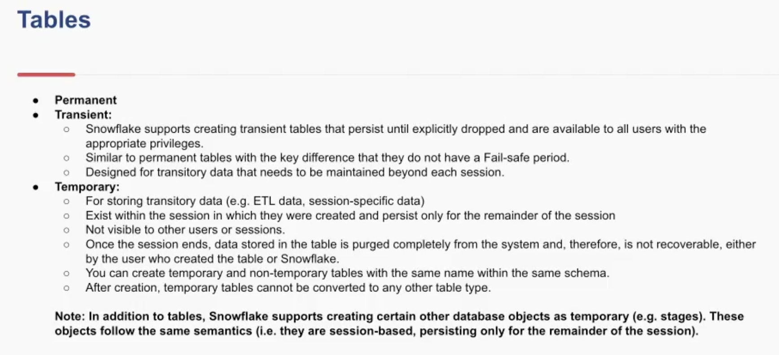

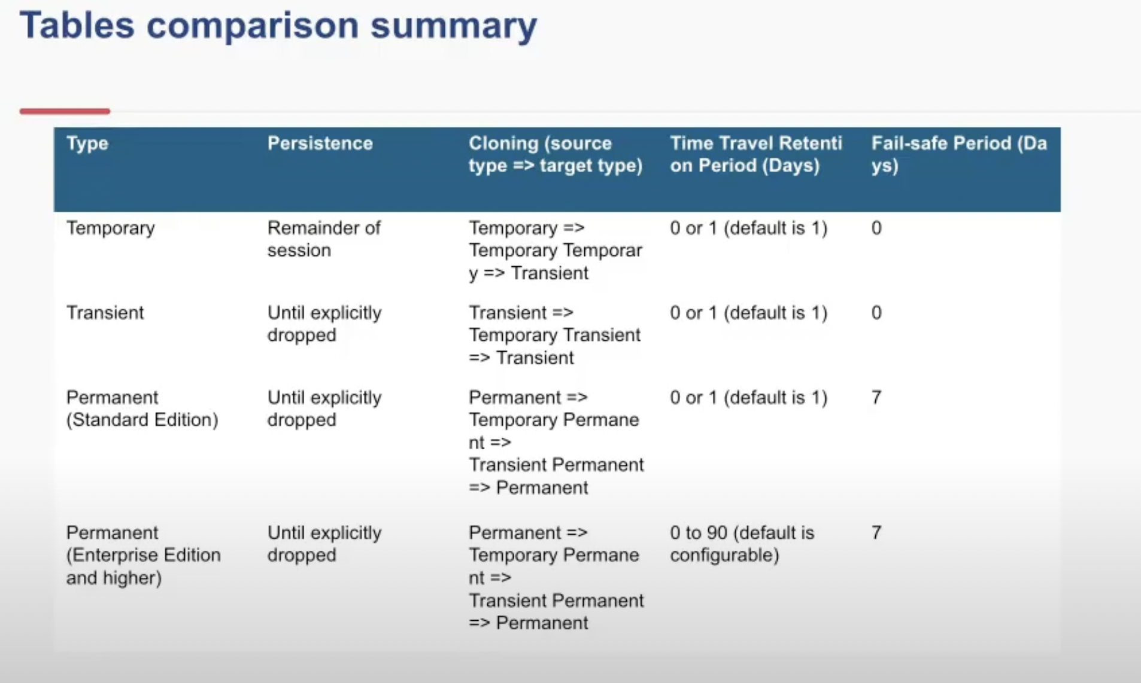

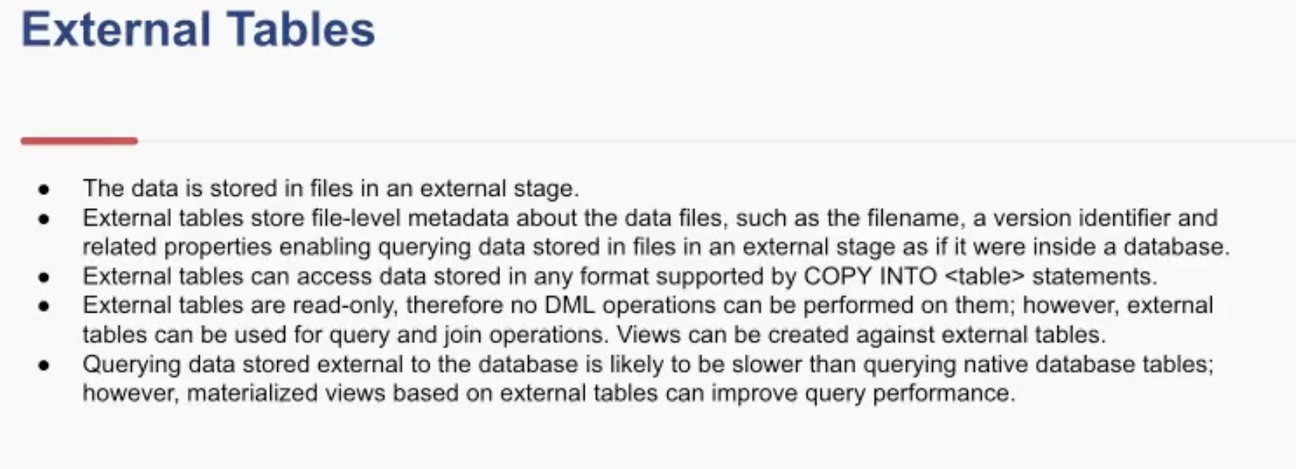

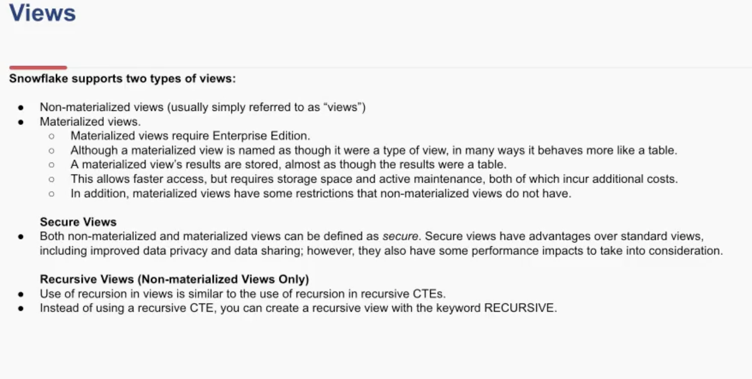

Recursive view is where we can re utilize the view in its body

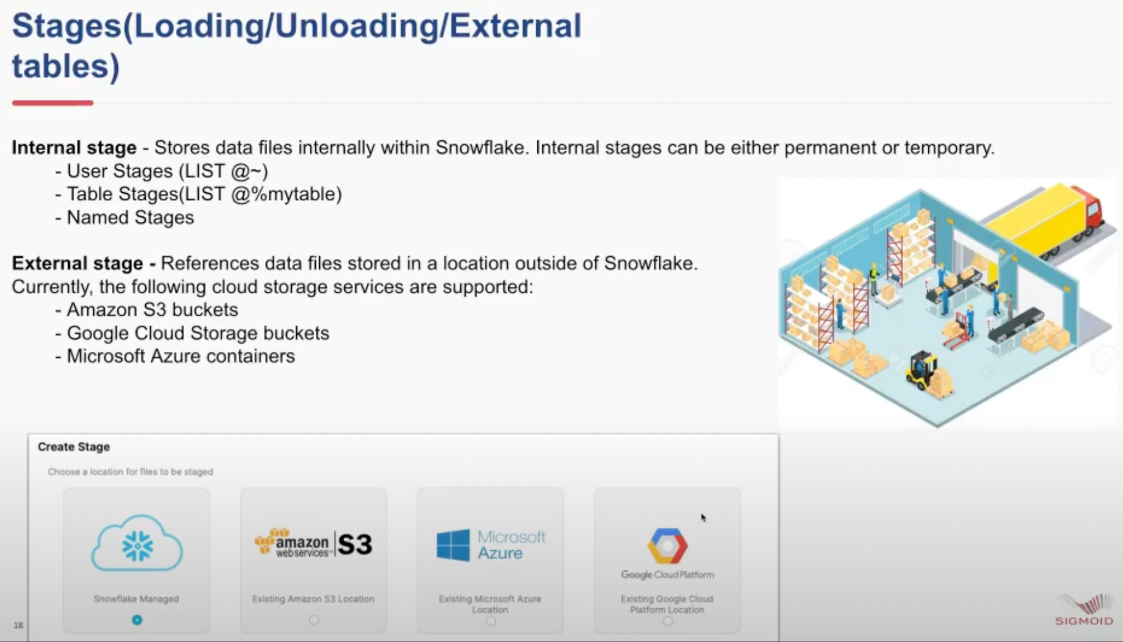

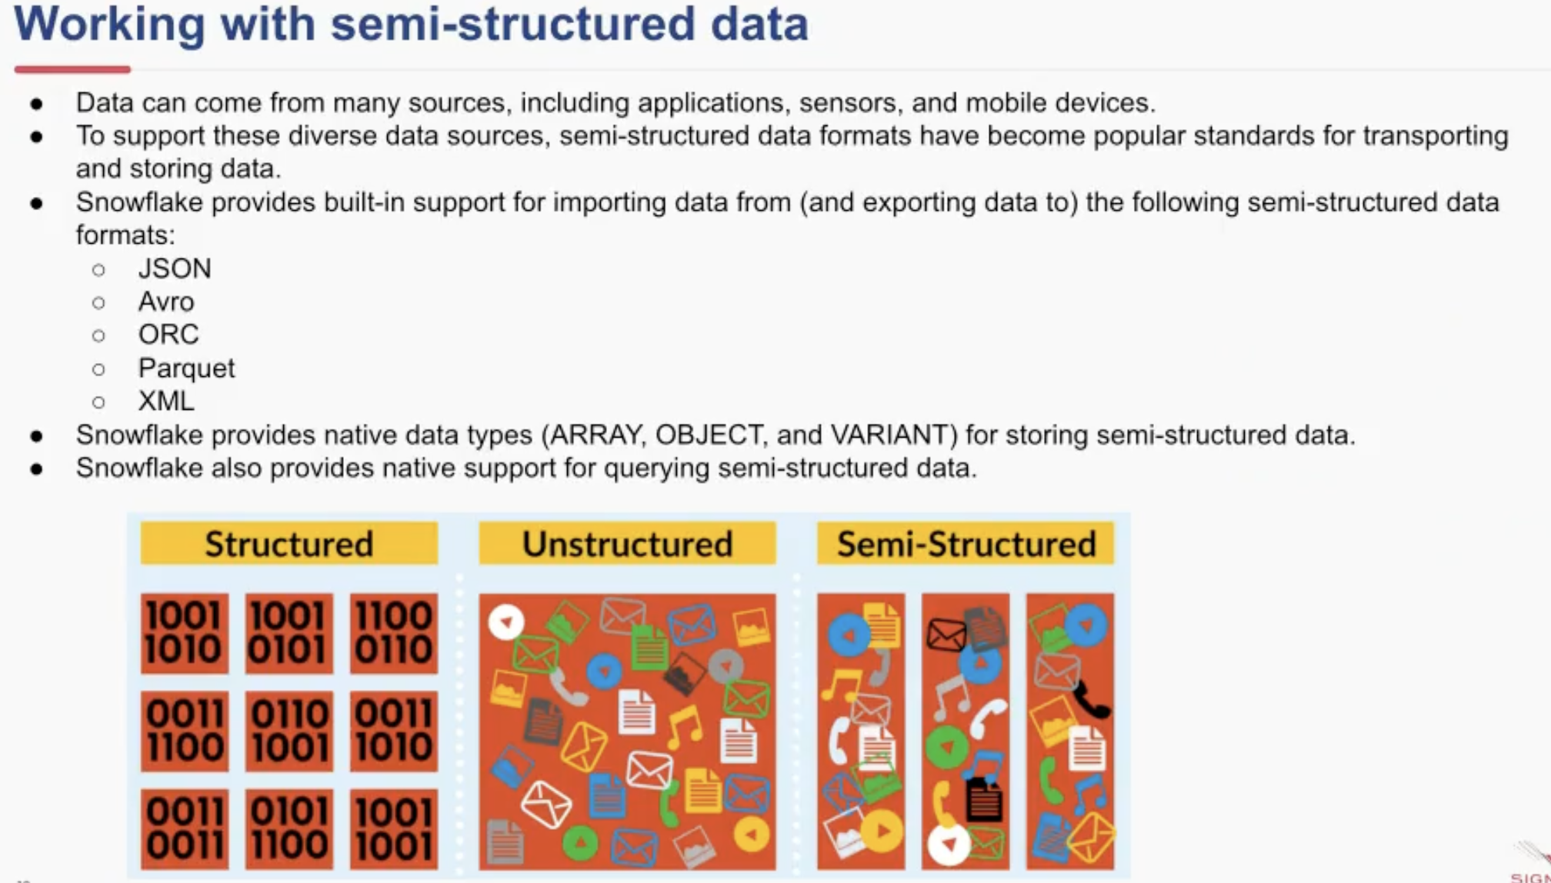

If data seems to change a lot ahead, variant data types can be used.

**Query ID, Query tag :** It can be useful for debugging. Query detail and query profile can be used to determine inefficient steps i.e. took a long time to execute, we can find the reason. Partitions scanned for it can be determined (Partition turning).

Snowpark is under development which will have a jupyter notebook . We can access the Snowflake data warehouse from a jupyter notebook using connectors.

**PART II:**

**EC2 SERVICES**:

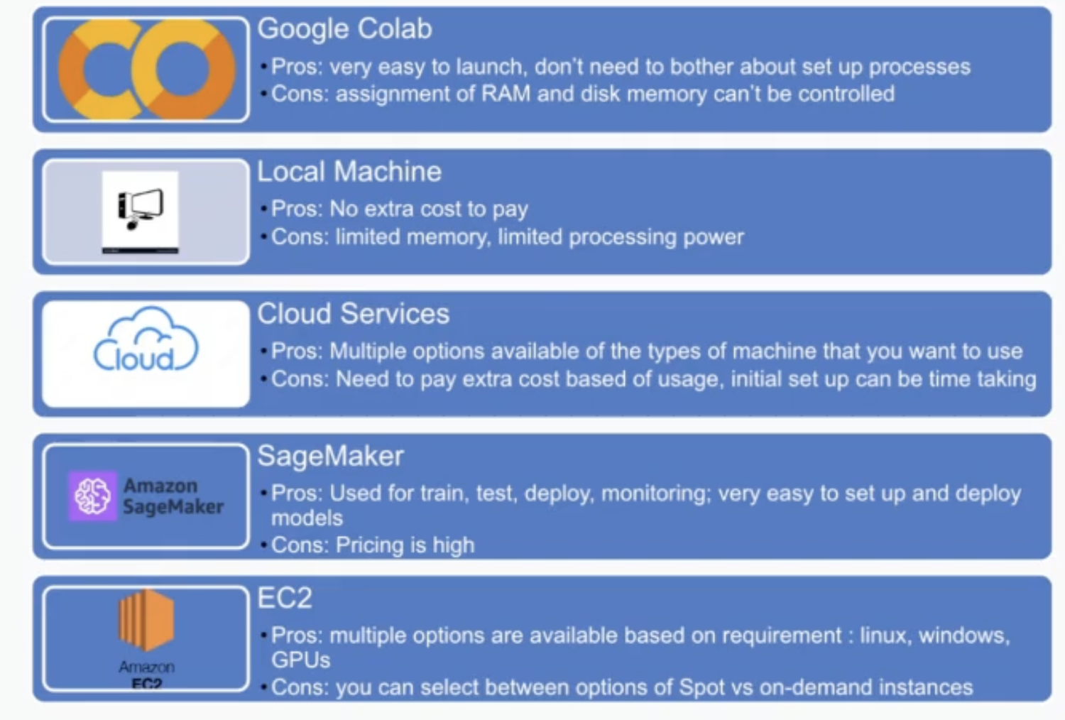

Colab: Even after paying we don’t know, how much memory we get.

Local Machine: Limited and M1 chip is under development thus we dont get much support

Client use SageMaker.

